COMP 357
The Mega
Hacking Project

Ishika Thakur
10325491
Introduction: This report documents a verified ethical and benign client-side security demonstration using the Browser Exploitation Framework (BeEF).
The goal was to demonstrate the impact on a browser when loading a web page containing a JavaScript link in a completely isolated virtual lab environment.

Lab Environment:
Attacker machine - Kali linux with IP 192.168.2.33
Victim Machine – Windows with IP 192.168.2.28
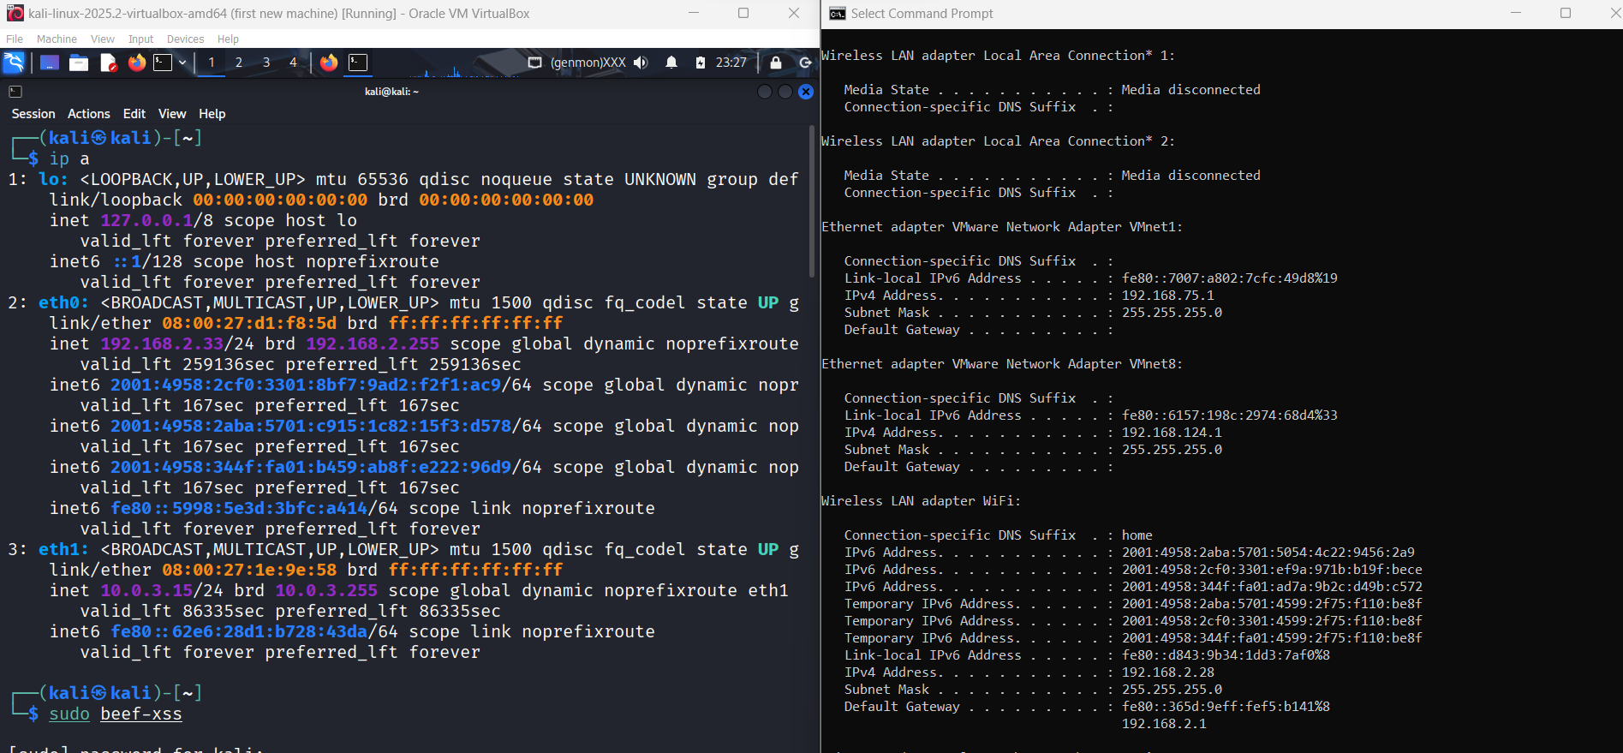

Attack scenario:
The purpose of the attack scenario was to illustrate the following:
- How a user's browser "hangs" after loading a web page with embedded JavaScript
- What types of harmless client-side interactions can be triggered?
- How can an attacker affect a browser in an isolated lab?
This mimics a common security problem: visiting an untrusted website that runs unexpected scripts.

Attack Execution:
- Browser Hooking: so we ran a scrip for this test webpage that should open on windows machine. The browser appeared in beEF’s online browsers list.

This confirmed that Java script was successfully loaded hook.
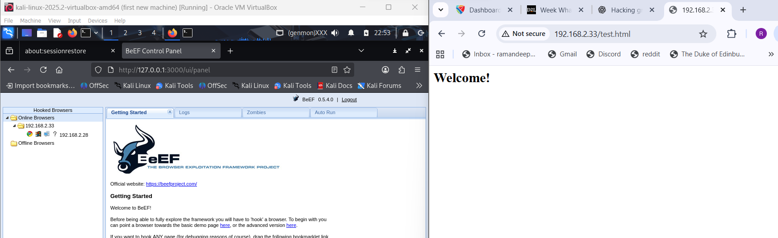

- Alert Pop-up: I used the Create Alert Dialog tool. So, I sent a small pop-up message to the victim’s browser saying, “This is a text message ALERTTT”. When executed the message it popped up on the victim’s browser screen as shown below in the screenshot. It shows hoe the browser was hooked and could receive commands from beEF.
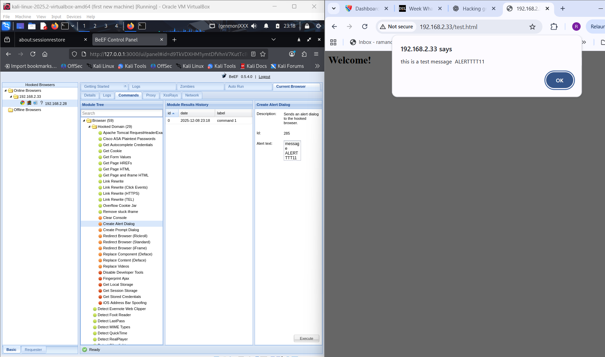

- Browser redirection: when I used the redirect browser tool, it redirected the victim’s browser to another page. After execution the victim’s browser automatically opened a new page. With this we learn that how beEF can change what site the user sees.
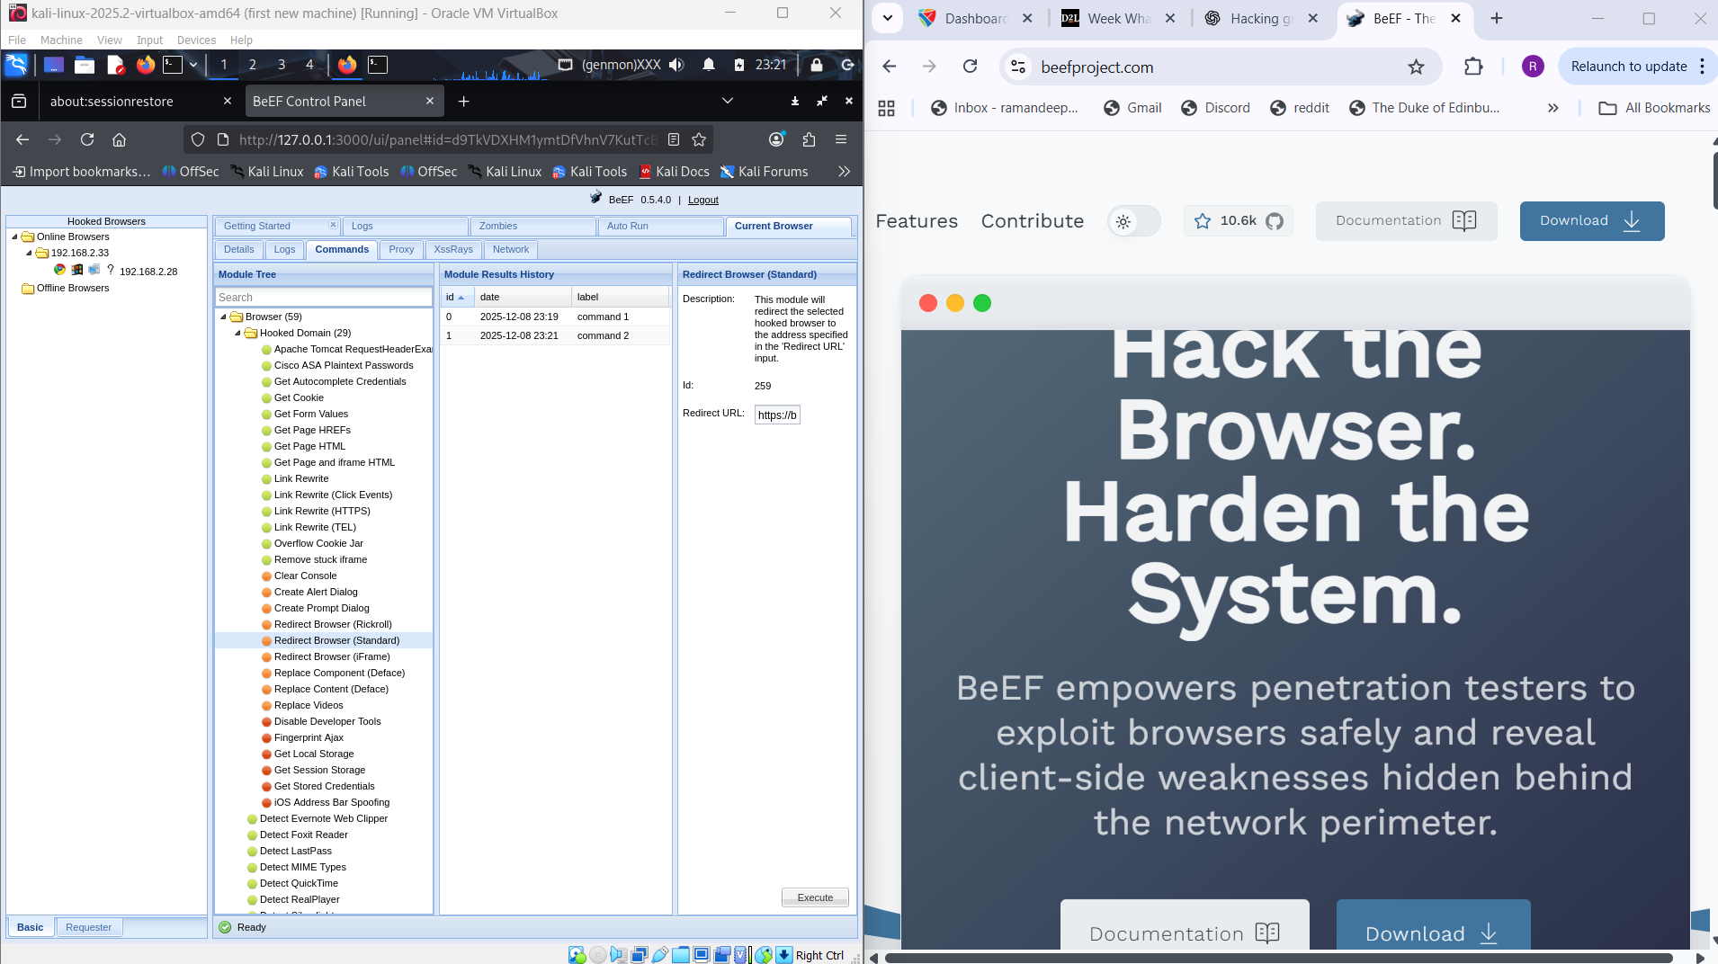

Conclusion: The BeEF demo successfully demonstrated the secure and controlled browser effect:
- A simple pop-up alert
- Harmless browser redirect
Both actions proved that the browser is turned on and able to run commands sent from the Control Panel.
These results will be used in the next phase of the project to develop mitigation measures to prevent unauthorized browser scripts.

